Date: 8th Jan 2022

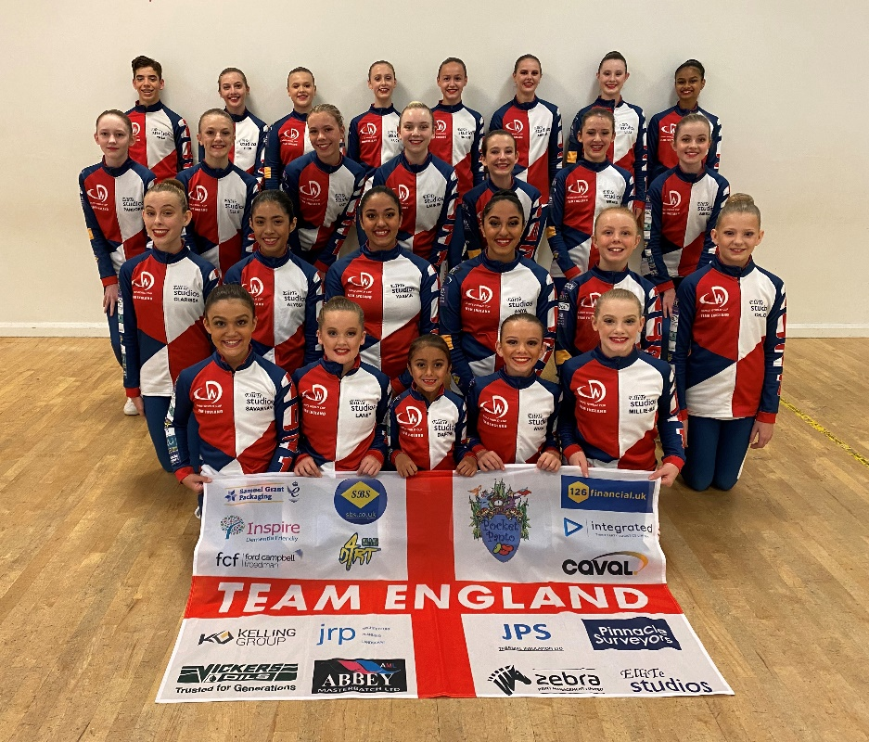

Ref: Corporate Sponsorship

Dear Sir / Madam,
Please allow me to introduce myself. My name is Samantha Bell and I am the Director of ElliTe Productions Ltd, ElliTe Vocational Training Ltd and Principal / Owner of ElliTe Studios (www.ellitestudios.co.uk). ElliTe Studios is a leading dance school in the centre of Wakefield where children age 3+ can learn to dance for fun/recreation or with aspirations to progress onto our vocational courses in preparation for pursuing a professional career in Musical Theatre, Dance, Choreography or Teaching.
The school has been established in Wakefield City Centre for 15 years now and in that time we have had hundreds of young people use our training facilities, come along to our classes and learn life-long transferable skills that have launched them into successful careers both within this industry and beyond. Our successful graduation destination rate is exceptional.
In 2018-19 we accomplished one of our biggest achievements yet by qualifying as the first ever Yorkshire based school to represent Team England in the Dance World Cup Finals in Portugal - the greatest all-genre dance competition in the world with 54 participating countries and 20,000 competitors. This was a huge honour and led to considerable media coverage on BBC Look North, BBC Radio Leeds as well as various other regional and national press articles, especially when Team England went on to win the World Cup.
We managed to capitalise on our success with ambitions to qualify again in 2019-2020 and 2020-2021 with an ever-increasing cast size of dancers. Following the rigorous audition and selection process, we were once again selected to represent the national team and ultimately our 30 dancers clinched 6 Golds, 8 Silvers, 7 Bronze Medals and 2 Overall Outstanding Awards in the combined finals earlier this year. After forging the way in 2018-19, we were once again proud to be the largest ever Yorkshire based contributors to the World Cup winning England team.
The incredible news for 2022 is that our young dancers have done it again! We have an astounding total of 25 different qualifying pieces showcasing the work of five local choreographers in genres as diverse as Classical Ballet, Tap, Jazz, Lyrical and Contemporary. This is our largest range of qualifying work to date and incorporates dancers from age 7-22. Being able to provide such a prestigious international platform for so many Yorkshire based young dancers and former pupils (as choreographers) is really special and certainly newsworthy. It’s even more incredible when you consider that all of this has been achieved despite the challenges and disruption of the pandemic on young people’s education and training.
The 2022 Finals are taking place in San Sebastian, Spain from June 24th – July 2nd. Publicity will be considerable and the event itself is live streamed to global audiences on all devices. Dancers attending the Dance World Cup Finals traditionally seek sponsorship from local and national companies to help fund the team kit, the event entry fees and costuming. We welcome sponsorship of any amount, but also have a couple of corporate sponsorship packages for guidance as follows:
- £500 sponsorship of the Team Kit and Team England flags – Like the Olympics and other global sporting events, there is a new compulsory team kit each year for Team England. This is worn by all dancers on the journey to and from the event, at all times at the Dance World Cup Finals, during the opening and closing ceremonies, on stage at the adjudications and at dance events throughout the rest of the year. Names / logos of corporate sponsors are added down the arms of the tracksuit tops (see photo). Previous sponsors include Sky and McDonalds. For £500 sponsorship, companies get their logo on the team kit jacket sleeves, logo on our 3ft x 5ft Team England flags (used in promotional pictures, on social media and at the event), logo and links on our website, social media tags, display of logo at our studios (for a year) and in marketing material associated with our participation in the event.
- £300 sponsorship of the Team Kit. Name / logo down the arms of the team kit tracksuit tops (as above).
- £100 sponsorship of the ElliTe Studios England flag. Names / logos of corporate sponsors are displayed on our 3ft x 5ft England flags. The flags are used in promotional pictures, on social media and at the event.
- £100 sponsorship of logo and links on our website, social media tags and display of logo at our studios (for a year).
- Any amount – bespoke sponsorship packages can be agreed for any amount, greater or smaller, for elements of the team kit for example.
As the opportunity for exposure is quite large and on a global scale, we do hope that sponsoring our team kit / flag / participation is something you might be willing to consider. Association with such a positive activity that promotes physical health and fitness, well-being, creativity, career development, reducing social poverty and increasing opportunities for young people can help to increase brand visibility and product awareness. We can provide you with further details if required and I would welcome the opportunity to speak with you further about this if you’d like. More information about the Dance World Cup is available on the website www.dwcworld.com. For guidance, I have attached photos of our dancers in their team England kit from the 2020 and 2021 combined finals.
I appreciate any consideration you can give to this opportunity and look forward to hearing from you.

Ellite Studios
Trading as Ellite Productions Limited, Registered England & Wales No. 05953357

Tel: 07908 808696 www.ellitestudios.co.uk Email sam@ellitestudios.co.uk

Yours faithfully,

S Bell

Samantha Bell
Principal, ElliTe Studios
07908 808696
sam@ellitestudios.co.uk
