Date: 22nd December 2020

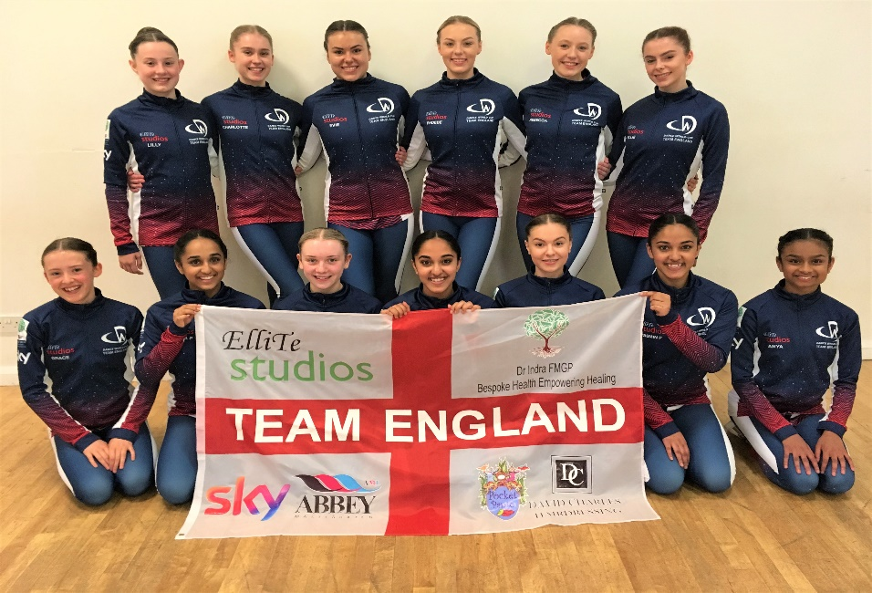

Ref: Corporate Sponsorship

Dear Sir / Madam,
Please allow me to introduce myself. My name is Samantha Bell and I am the Director of ElliTe Productions Ltd and Principal / Owner of ElliTe Studios (www.ellitestudios.co.uk). ElliTe Studios is a leading dance school in the centre of Wakefield where children age 3-18 can dance for fun or with aspirations to pursue a professional career in Musical Theatre, Dance, Choreography or Teaching.
The school has been established for 12.5 years now and in that time we have had hundreds of young people use our training facilities, come along to our classes and represent us at local and national competitions. Earlier this year we accomplished one of our biggest achievements yet by qualifying to represent Team England in the 2019 Dance World Cup Finals in Portugal. Open to all dancers from non-state run schools, the Dance World Cup is the greatest all-genre dance competition in the world with 54 participating countries and 20,000 competitors. Ultimately, Team England were crowned World Cup winners 2019 and as the first and only team to have ever qualified from Yorkshire, we received quite considerable media coverage for our achievement, including a package on BBC Look North, BBC Radio Leeds and various other press articles.
Now pupils have done it again and have qualified in a whopping seven sections for the 2020 Dance World Cup Finals. We will be taking 15 children aged 10 – 16 to Rome at the end of June / beginning of July to try to win Gold in their sections – Children’s Boys Ballet solo, Children’s Ballet Large Group, Junior Girls Ballet solo, Junior Ballet Quartet, Children’s Pas De Deux, Children’s Boys Lyrical Solo and Junior Tap Duet. Publicity is already considerable - a new fly-on-the-wall TV documentary has been commissioned about all the UK Teams 2020 and we will be looking for even more mainstream media and Social Media coverage of our preparations and participation this time. The event itself is also live streamed to global audiences on all devices.

Dancers travelling to the Dance World Cup Finals traditionally seek sponsorship from local and national companies to help fund the team kit and / or the trip itself. We welcome sponsorship of any amount, but also have a couple of corporate sponsorship packages for guidance as follows:
- £500 sponsorship of the Team Kit and Team England flag – Like the Olympics and other global sporting events, there is a new compulsory team kit each year for Team England. This is worn by all dancers on the journey to and from Rome, at all times at the Dance World Cup venue in Rome, during the opening and closing ceremonies, on stage at the adjudications and at dance events throughout the rest of the year. Names / logos of corporate sponsors are added down the arms of the tracksuit tops (see photo). Previous sponsors include Sky and McDonalds. For £500 sponsorship, companies get their logo on the team kit jacket sleeves, logo on our 3ft x 5ft Team England flag (used in promotional pictures, on social media and at the event), a ½ page advert in our show programme, logo on our website and social media tags. Deadline 01/04/2020.
- £300 sponsorship of the Team Kit. Name / logo down the arms of the team kit tracksuit tops (as above), logo on our website and social media tags. Deadline 01/04/2020
- £70 sponsorship of the ElliTe Studios England flag. Names / logos of corporate sponsors are displayed on our 3ft x 5ft England flags. The flags are used in promotional pictures, on social media and at the event. Also includes social media tags. Deadline 01/06/2020.
- Any amount – bespoke sponsorship packages can be agreed for any amount, greater or smaller.
As the opportunity for exposure is quite large and on a global scale, we do hope that sponsoring our team kit / flag / trip is something you might be willing to consider. We can provide you with further details if required and I would welcome the opportunity to speak with you further about this if you’d like. More information about the Dance World Cup is available on the website www.dwcworld.com. For guidance, I have attached photos of our dancers in their team England kit from the 2019 Finals.
I appreciate any consideration you can give to this opportunity and look forward to hearing from you.

Ellite Studios, The Dancer 8 Peterson Road Wakefield WF1 4EB
Trading as Ellite Productions Limited, Registered England & Wales No. 05953357

Tel 0845 652 5361 Email enquiries@ellitestudios.co.uk
Mobile 07908 808 696 www.ellitestudios.co.uk

Yours faithfully,

S Bell

Samantha Bell
Principal, ElliTe Studios
07908 808696
sam@ellitestudios.co.uk

